SIMATS ENGINEERING
ASSESSMENT TOOL 1: Expert System Development Project
COURSE NAME: ARTIFICIAL INTELLIGENCE COURSE CODE: MLA01
AND EXPERT SYSTEMS

COURSE OUTCOME COVERED
CO 5: Construct rule-based expert systems using production rules, forward and backward chaining, and by distinguishing procedural and non-procedural paradigms across development stages.(BTL 3)
Assessment Tool Weightage: 40%

Total Marks: 100 Time: 90 Mins
No. of Questions: 1
Annexure A
Expert System Development Project

Code of Conduct:
I ____________________ (Name / Reg No) certify that this submission is my original work and that I have adhered to the guidelines specified for this assessment.
I understand that any violation of academic integrity rules will result in disciplinary action. Signature of the student:
Criterion | Weightage | Marks Obtained
1. Problem Analysis and Domain Understanding | 10%
2. Knowledge Acquisition and Knowledge Representation | 10%
3. Production Rule / Knowledge Base Design | 15%
4. Prolog Implementation and Programming | 15%
5. Forward Chaining Implementation and Demonstration | 10%
6. Backward Chaining Implementation and Demonstration | 10%
7. Procedural and Non-Procedural Paradigm Analysis | 10%
8. Unification, Backtracking and Inference Accuracy | 10%
9. Testing, Results and System Demonstration | 5%
10. Documentation, GitHub Repository and Technical Presentation | 5%
Total | 100%
Signature of the Faculty Total Marks Awarded
ANSWER ANY ONE OF THE FOLLOWING
Tool: SWI-Prolog
Usage of Prolog: Students shall use Prolog to develop a rule-based expert system by representing domain knowledge as facts and production rules, and implementing reasoning through forward and backward chaining. The project should demonstrate Prolog's declarative/non-procedural nature, logical inference, rule matching, and automated conclusion generation.
S.No. | Scenario-Based Expert System Development Question
1 | Automobile Fault Diagnosis System:  Design an expert system that identifies probable vehicle faults based on symptoms such as engine noise, starting problems, warning indicators, abnormal vibration, and reduced mileage. Implement the knowledge base using production rules and compare forward and backward reasoning.

AUTOMOBILE FAULT DIAGNOSIS EXPERT SYSTEM
1. ABSTRACT
The Automobile Fault Diagnosis Expert System is a rule-based expert system developed using SWI-Prolog. It identifies probable automobile faults from symptoms such as starting problems, overheating, brake noise, reduced mileage, and steering vibration. The system uses production rules with forward and backward chaining to derive possible faults.
2. INTRODUCTION
Automobile fault diagnosis requires identifying the possible cause of a problem from observed symptoms. This project uses Artificial Intelligence and Prolog to automate this process using facts and IF–THEN rules. The system provides a simple and explainable preliminary diagnosis.
3. PROBLEM ANALYSIS
Problem: Identify probable vehicle faults from observed symptoms.
Inputs:
- Starting problems
- Abnormal sounds
- Overheating
- Brake problems
- Reduced mileage
- Steering vibration
Outputs:
- Weak battery
- Cooling system fault
- Brake fault
- Engine tuning problem
- Wheel alignment problem
4. KNOWLEDGE ACQUISITION
Automobile symptoms and their possible causes are collected and represented as facts and production rules.
Example:
IF engine does not start AND clicking sound AND dim headlights
THEN weak battery.
5. KNOWLEDGE REPRESENTATION
The system represents knowledge using:
- Facts – observed symptoms.
- Rules – relationships between symptoms and faults.
- Conclusions – probable automobile faults.
Example:
rule(weak_battery, [engine_wont_start, clicking_sound, headlights_dim]).
6. PRODUCTION RULES
Symptoms | Diagnosis
Engine won't start + clicking + dim headlights | Weak battery
Engine overheating + low coolant | Cooling system fault
Brake noise + squealing | Worn brake pads
Reduced mileage + misfire + check-engine light | Engine tuning problem
Steering vibration + pulling to one side | Wheel alignment problem

7. SYSTEM ARCHITECTURE

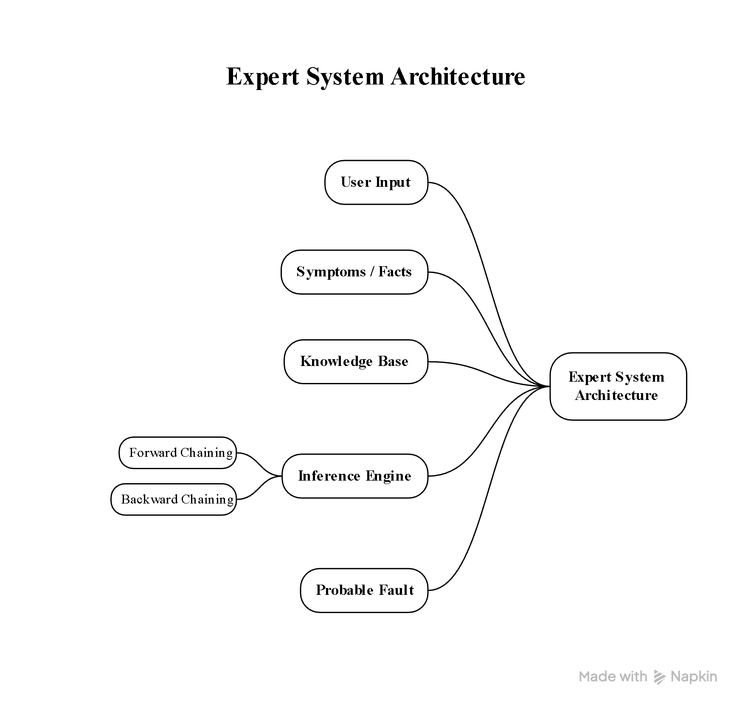
8. FORWARD CHAINING
Forward chaining is data-driven reasoning. It starts with known symptoms and applies matching rules to derive a diagnosis.
Example:
Symptoms → Engine won't start + Clicking sound + Dim headlights
Rule → Weak Battery
Result → Weak Battery
9. BACKWARD CHAINING
Backward chaining is goal-driven reasoning. It starts with a suspected fault and checks whether the required symptoms are available.
Example:
Goal → Weak Battery
Check required symptoms → Engine won't start + Clicking sound + Dim headlights
Result → Diagnosis proved
10. PROCEDURAL AND NON-PROCEDURAL APPROACH
Procedural: Specifies the sequence of steps to solve the problem.
Non-procedural: Represents facts and rules, allowing the system to derive conclusions logically.
Prolog mainly follows a declarative/non-procedural approach.
11. UNIFICATION AND BACKTRACKING
Unification matches queries with facts and rules.
Backtracking allows Prolog to try another possible rule when the current reasoning path fails.
These features help Prolog search for valid diagnoses.
12. TESTING
Test | Input | Expected Result
1 | Starting + clicking + dim headlights | Weak battery
2 | Overheating + low coolant | Cooling system fault
3 | Brake noise + squealing | Worn brake pads
4 | Reduced mileage + misfire | Engine tuning problem
5 | Vibration + pulling to one side | Wheel alignment
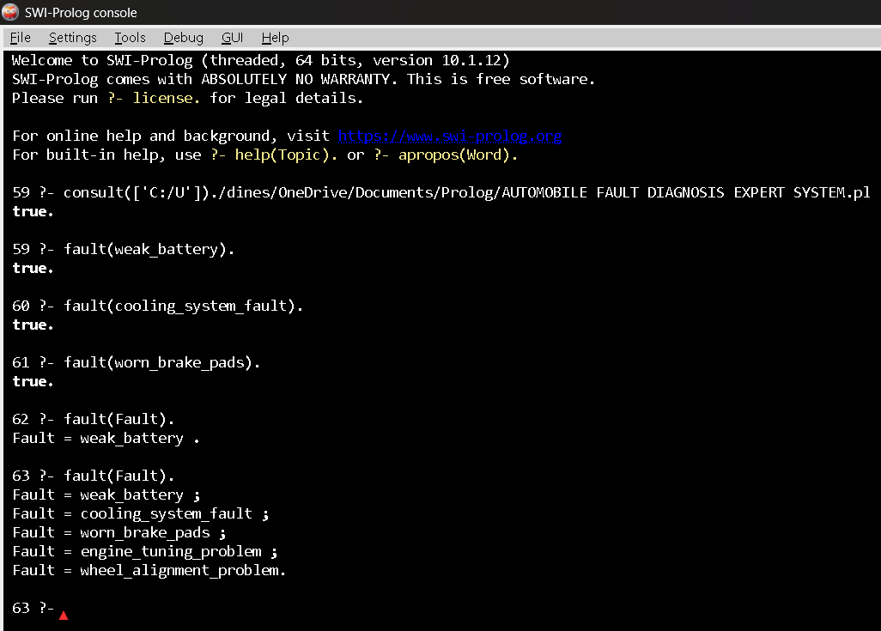
13. RESULTS
The system successfully matches automobile symptoms with production rules and produces probable faults. Both forward and backward chaining can be used to demonstrate the reasoning process.
14. LIMITATIONS
- . Limited number of symptoms and faults.
- No real-time vehicle sensor data.
- No OBD-II integration.
- Intended for educational purposes.
15. FUTURE ENHANCEMENTS
- Add more vehicle faults.
- Add OBD-II support.
- Add a graphical interface.
- Add vehicle-specific diagnosis.
- Add confidence/probability scores.
16. CONCLUSION
The Automobile Fault Diagnosis Expert System demonstrates how Prolog and production rules can be used to identify probable vehicle faults. The system implements forward and backward chaining and demonstrates unification, backtracking, and logical reasoning.
17.REFERENCES
- Mustafa, E. M., Saad, M. M., & Rizkallah, L. W. (2023). Building an enhanced case-based reasoning and rule-based systems for medical diagnosis. Journal of Engineering and Applied Science, 70, 139.
- SWI-Prolog Developers. (2023). SWI-Prolog Documentation and Reference Manual. SWI-Prolog.
- Russell, S. J., & Norvig, P. (2023). Artificial Intelligence: A Modern Approach. 4th Edition, Pearson.

Report Format:
Stage | Student Activity | Expected Output
1. Domain Analysis | Identify the problem domain, entities, facts, symptoms/conditions, and possible conclusions. | Problem definition and domain model
2. Knowledge  Acquisition | Collect domain knowledge from reliable sources or domain experts. | Knowledge  specification
3. Knowledge  Representation | Convert domain knowledge into IF–THEN production rules. | Knowledge base
4. Inference Design | Implement forward chaining and backward chaining. | Inference engine
5. Paradigm  Analysis | Distinguish how the solution can be expressed using procedural and non-procedural approaches. | Paradigm comparison
6. System  Development | Integrate the knowledge base, inference engine, user interface, and explanation facility. | Working expert system
7. Testing | Test the system using multiple facts and scenarios. | Test cases and outputs
8. Evaluation | Analyze correctness, coverage, consistency, and reasoning performance. | Evaluation results
9. Documentation | Prepare technical documentation and GitHub repository. | Project report +  GitHub
10. Demonstration | Demonstrate the system and explain the reasoning process. | Project presentation/viva
EVALUATION RUBRICS:
Criterion | Weightag e (%) | Excellent | Good | Average | Poor
1. Problem  Analysis and  Domain  Understanding | 10% | 9–10% – Clearly analyzes the real-world problem, domain  entities, facts, conditions, goals, and expected conclusions. | 7–8% – Good understanding of the domain with minor omissions. | 5–6% – Basic domain understanding with several missing elements. | 0–4% – Poor or incorrect understanding of the problem domain.
2. Knowledge  Acquisition and  Representation | 10% | 9–10% – Acquires relevant domain knowledge and represents it accurately using well-structured Prolog facts and rules. | 7–8% – Knowledge is appropriately represented with minor gaps. | 5–6% – Basic knowledge representation with missing or unclear facts/rules. | 0–4% –  Inadequate or inappropriate knowledge representation.
3. Production  Rule /  Knowledge  Base Design | 15% | 13–15% – Develops a comprehensive, consistent, and logically structured production-rule knowledge base with appropriate facts and rules. | 10–12% – Well-designe d knowledge base with minor inconsistencie s or omissions. | 7–9% – Basic rule base developed but several rules are incomplete or unclear. | 0–6% –  Knowledge base is incomplete, inconsistent, or inappropriate.
4. Prolog  Implementation | 15% | 13–15% –  Implements a fully functional expert system using Prolog facts, predicates, rules, variables, unification, and backtracking effectively. | 10–12% – Functional Prolog implementati on with minor technical issues. | 7–9% – Basic implementation works with limited use of  Prolog features. | 0–6% –  Implementation is incomplete, incorrect, or non-functional.

5. Forward  Chaining | 10% | 9–10% – Correctly implements and demonstrates forward chaining from initial facts through applicable rules to final conclusions. | 7–8% – Forward chaining works correctly with minor limitations. | 5–6% – Basic forward reasoning demonstrated but with incomplete rule processing. | 0–4% – Forward chaining is missing or incorrectly implemented.
6. Backward  Chaining | 10% | 9–10% –  Effectively demonstrates goal-driven backward chaining using Prolog's inference mechanism and  clearly traces the reasoning process. | 7–8% – Backward chaining works correctly with minor gaps. | 5–6% – Basic backward reasoning demonstrated with limited explanation. | 0–4% –  Backward  chaining is missing or incorrectly implemented.
7. Procedural and  Non-Procedural  Paradigm  Analysis | 10% | 9–10% – Clearly distinguishes procedural and declarative/non-pr ocedural approaches and demonstrates their application in the Prolog system. | 7–8% –  Provides a good distinction with minor conceptual gaps. | 5–6% – Basic distinction is explained but lacks practical demonstration. | 0–4% – Paradigms are misunderstood or not addressed.
8. Inference,  Unification and  Reasoning  Accuracy | 10% | 9–10% – Produces accurate conclusions using unification, backtracking, and logical inference across diverse test cases. | 7–8% –  Reasoning is mostly accurate with minor errors. | 5–6% – Basic inference works but produces occasional incorrect results. | 0–4% –  Inference is unreliable or incorrect.
9. Testing,  Results and  System  Demonstration | 5% | 5% – Provides comprehensive  test cases, accurate outputs, reasoning traces, and a convincing live demonstration. | 4% – Good testing and demonstration with minor gaps. | 2–3% – Limited test cases and basic demonstration. | 0–1% – Testing or demonstration  is  missing/inadequa te.
10.  Documentation,  GitHub and  Technical  Presentation | 5% | 5% – Complete documentation, well-organized GitHub repository, clear code, references, and professional presentation. | 4% – Good documentatio n and repository with minor issues. | 2–3% – Basic documentation/re pository with several omissions. | 0–1% – Poor documentation, missing repository, or inadequate presentation.
Total | 100%

